**JAVASCRIPT**

JavaScript is the world's most popular programming language.

JavaScript is the programming language of the Web.

getElementById() use of this method:

The getElementById() method is one of the most common methods in the HTML DOM. It is used almost every time you want to read or edit an HTML element.

The getElementById() method returns an element with a specified value.

<!DOCTYPE html>

<html>

  <body>

    <h2>What Can JavaScript Do?</h2>

    <p id="demo">JavaScript can change HTML content.</p>

    <button

      type="button"

      onclick='document.getElementById("demo").innerHTML = "Hello JavaScript!"'

    >

      Click Me!

    </button>

  </body>

</html>

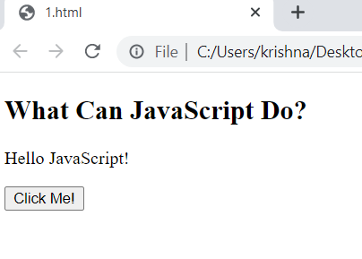

<!DOCTYPE html>

<html>

  <body>

    <h2>My First JavaScript</h2>

    <button

      type="button"

      onclick="document.getElementById('demo').innerHTML = Date()"

    >

      Click me to display Date and Time.

    </button>

    <p id="demo"></p>

  </body>

</html>

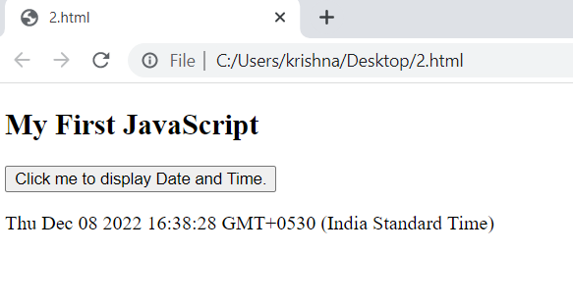

<!DOCTYPE html>

<html>

  <body>

    <img

      id="myImage"

      onclick="changeImage()"

      src="pic_bulboff.gif"

      width="100"

      height="180"

    />

    <p>Click the light bulb to turn on/off the light.</p>

    <script>

      function changeImage() {

        var image = document.getElementById("myImage");

        if (image.src.match("bulbon")) {

          image.src = "pic_bulboff.gif";

        } else {

          image.src = "pic_bulbon.gif";

        }

      }

    </script>

  </body>

</html>

